Water Jug Problem
Aim
To solve the Water Jug Problem using Artificial Intelligence state-space search.
Objective
To obtain the desired quantity of water using two jugs of different capacities.
Algorithm
- Start with both jugs empty.
- Fill one jug completely.
- Transfer water from one jug to another.
- Empty a jug when necessary.
- Repeat until the target quantity is obtained.
- Stop when the goal state is reached.
Flowchart
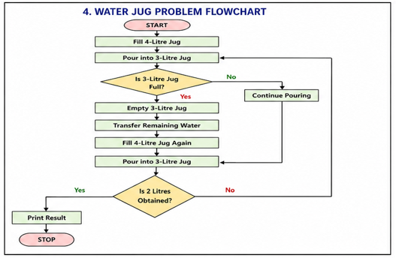

Sample Output
Water Jug Steps:
4L Jug = 4 3L Jug = 0
4L Jug = 1 3L Jug = 3
4L Jug = 1 3L Jug = 0
4L Jug = 0 3L Jug = 1
4L Jug = 4 3L Jug = 1
4L Jug = 2 3L Jug = 3
Python Code:
state = (0, 0)
goal = 2

while True:
print(state)

x, y = state

if x == goal or y == goal:
print("Target Achieved")
break

if x < 4:
state = (4, y)
elif y < 3:
transfer = min(x, 3 - y)
state = (x - transfer, y + transfer)
elif y == 3:
state = (x, 0)
Output:
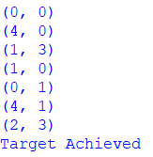

Result:
The target quantity of water was successfully obtained.
Conclusion:
The Water Jug Problem was solved using state-space search techniques.

